
Boxplot of sales
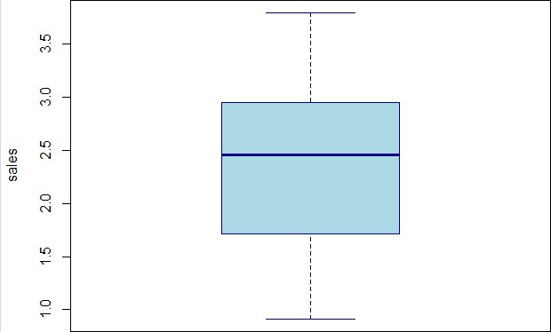
Data
Editor
File Edit Help
 |  |  |  |  | vars | Val 6
 | Atlanta Braves | 3 . 361 | sg.S36
 | New York Mets | 2 . 288 | 49. SIB
 | Philadelphia Phil I i es | . 716 | sq. 37
 | Florida Marlins | . 914 | g . 162
 | Hcuston As t IOS | . 75 | SS. 434 | 12
6 | Chicago Cubs | 2 . 45 | 40 . 629
 | St . Lcmis Cardinals | 2 . 623 | 49 . 433
 | Cincinnati Reds | us | S2.S7S
 | Milwaukee Brewers |  | 21 . ges
 | Pittsburgh Pirates | 812 | 32 . 393 | 46
 | San Diego Padres |  | 13 . 352
12 | San Francisco Giants | 2.ss6 | 45 . 368
13 | Colorado Rockies | 1 . 926 | 40. Sil
14 | zona Diamondbacks | 089 | 47 . 97
 | New York Yankees | 3 . 789 | 47 . 435
16 | Boston Red Sox | 3 . 603 | 30 . 572
17 | Toronto Blue Jays |  | 63 . 461 | 76
18 | Baltimore Orioles | 2. S 44 | 51 . 647 | 87
 | Tampa Bay Devil | 2 . 454 | . 666 | 10

